Things to know

about the

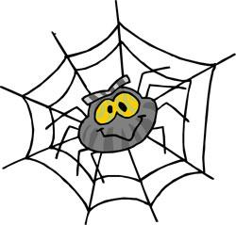

World Wide Web

How big is the World Wide Web (www)?
The www is HUGE! BUT…did you know that less than HALF of the www is able to be searched? And popular search engines actually search less than HALF of that amount! A Metasearch Engine should be used to search the “deep web”.
What is a Web Browser?
A web browser is program on your computer that allows you to visit web sites. You get to your web browser by clicking on the icon (examples are Internet Explorer or Firefox). This is the most important piece of software on a computer because every web page runs through it. |   

What is a search engine?
A search engine is a BIG web site that is used to search the www. The most popular search engines are


&


is a great Metasearch Engine that will search the “deep web” and “cluster” the information it retrieves by putting it into categories.

How do search engines work??
Search engines use “spiders” to do the work for them!!! The spiders are also called “crawlers” or “knowledge bots” or “knowbots”. They roam the www, visit web sites and keep the search engine up to date. They find new pages, update pages, and delete ones no longer in use. Most large search engines have LOTS of spiders. But the web is so HUGE that it can take up to six months for the spiders to cover it.
What is the difference between a web site and a web page? A web site is the center for a bunch of web pages on the same topic. There are at least a TRILLION web pages in existence (Kelly, What Technology Wants).
Web Site
Web Page
Web Page
Web Page
Web Page

What is a web address?
The fancier name for a web address is URL (Uniform Resource Locator). Every house has an address and every web site and web page has an address too!

Example: http://www.westervillelibrary.org
Type of file
Hypertext transfer protocol = type of language
world wide web
Domain name
extension

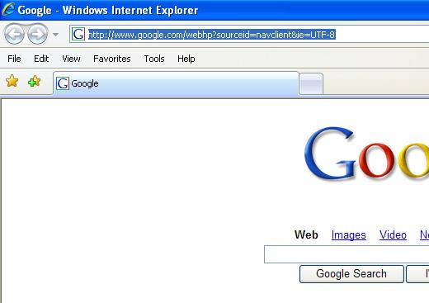

Look out! Sometimes when you click on a web page inside a web site the web address will change!

Should we believe what we find on the www?
Most web sites can give you great information. BUT…not everything on the www is TRUE!!

How can we tell if something we read is true?
The best way to tell if something is true is to compare the information to other sources like:
- Other web sites
- BOOKS!!!!!
- Magazines
- Etc.
What kinds of web sites give us good information?
Web addresses with the best information end in:
.edu (usually a college or university)
.gov (government agency)
.k12 (Kindergarten through grade 12 school)

What kind of web sites should we question?
Ones to watch out for (because anyone can make or buy these) are ones that have the following ending in their address:
.com (company .co is a company in Britain)
.org (organization these usually have pretty good info)
.net (network)

What are some clues for telling us if we’re on a personal web site (which means there might be a lot of opinions not facts). If you see the following in the web address, you’re probably on a personal web site:

person’s name | for example jdoe
tilde | ~
percentage sign | %
the following words | users, people, members
Even if a site ends with .edu, you still need to keep a look out for personal pages!
How can I find the “author” of a web site I’m looking at?? When you are doing research on the www, you want to make you’re your information is true! Sometimes it helps to know who wrote the information you are reading. You can often find the owner (or publisher) of a web site by using Whois? Go to www.easywhois.com and enter the address (URL) of the site you would like to learn more about. ex. (http://zapatopi.net/treeoctopus/)
Interested in seeing what a webpage/site looked like months or years ago? Go to www.archive.org and click the “Take Me Back” button.

Are the first web sites that pop up in my search usually the best?
When you search the www, usually the most popular web sites (or the ones with the most links) are at the top of the list. But remember, the most popular web sites are not always the BEST web sites!!

What if I want to search for a word in a web site but there is no “search box”?
If there isn’t a search box on a web site, you can hold down the CTRL and F buttons on your keyboard (CMD-F on a Macintosh) and a search box will appear (usually at the bottom of the page) where you can type in the word you’re looking for.
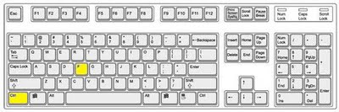

What is the best way to search the www?
Sometimes using double quotation marks around your words can help get a smaller amount of results – making it easier to find a web site with good information. The double quotation marks tell the search engine to look for web sites that have the exact words that you typed – in the exact order that you typed them.
For example: 28,600,000 results when I typed:

famous U.S. basketball players

BUT….I only received 425 results when I typed:

“famous U.S. basketball players”

This part takes practice!! Try connecting your search words by using (Boolean):

OR | Spiders will search web sites that contain either of the words you type.
NOT | Spiders will search web sites for a word you type but NOT the other word(s).
AND | Spiders will search web sites that contain all of the words you type.

You want to find camps in Westerville Ohio that have EITHER basketball OR soccer.  Type in search box:  Basketball OR soccer camps Westerville Ohio | 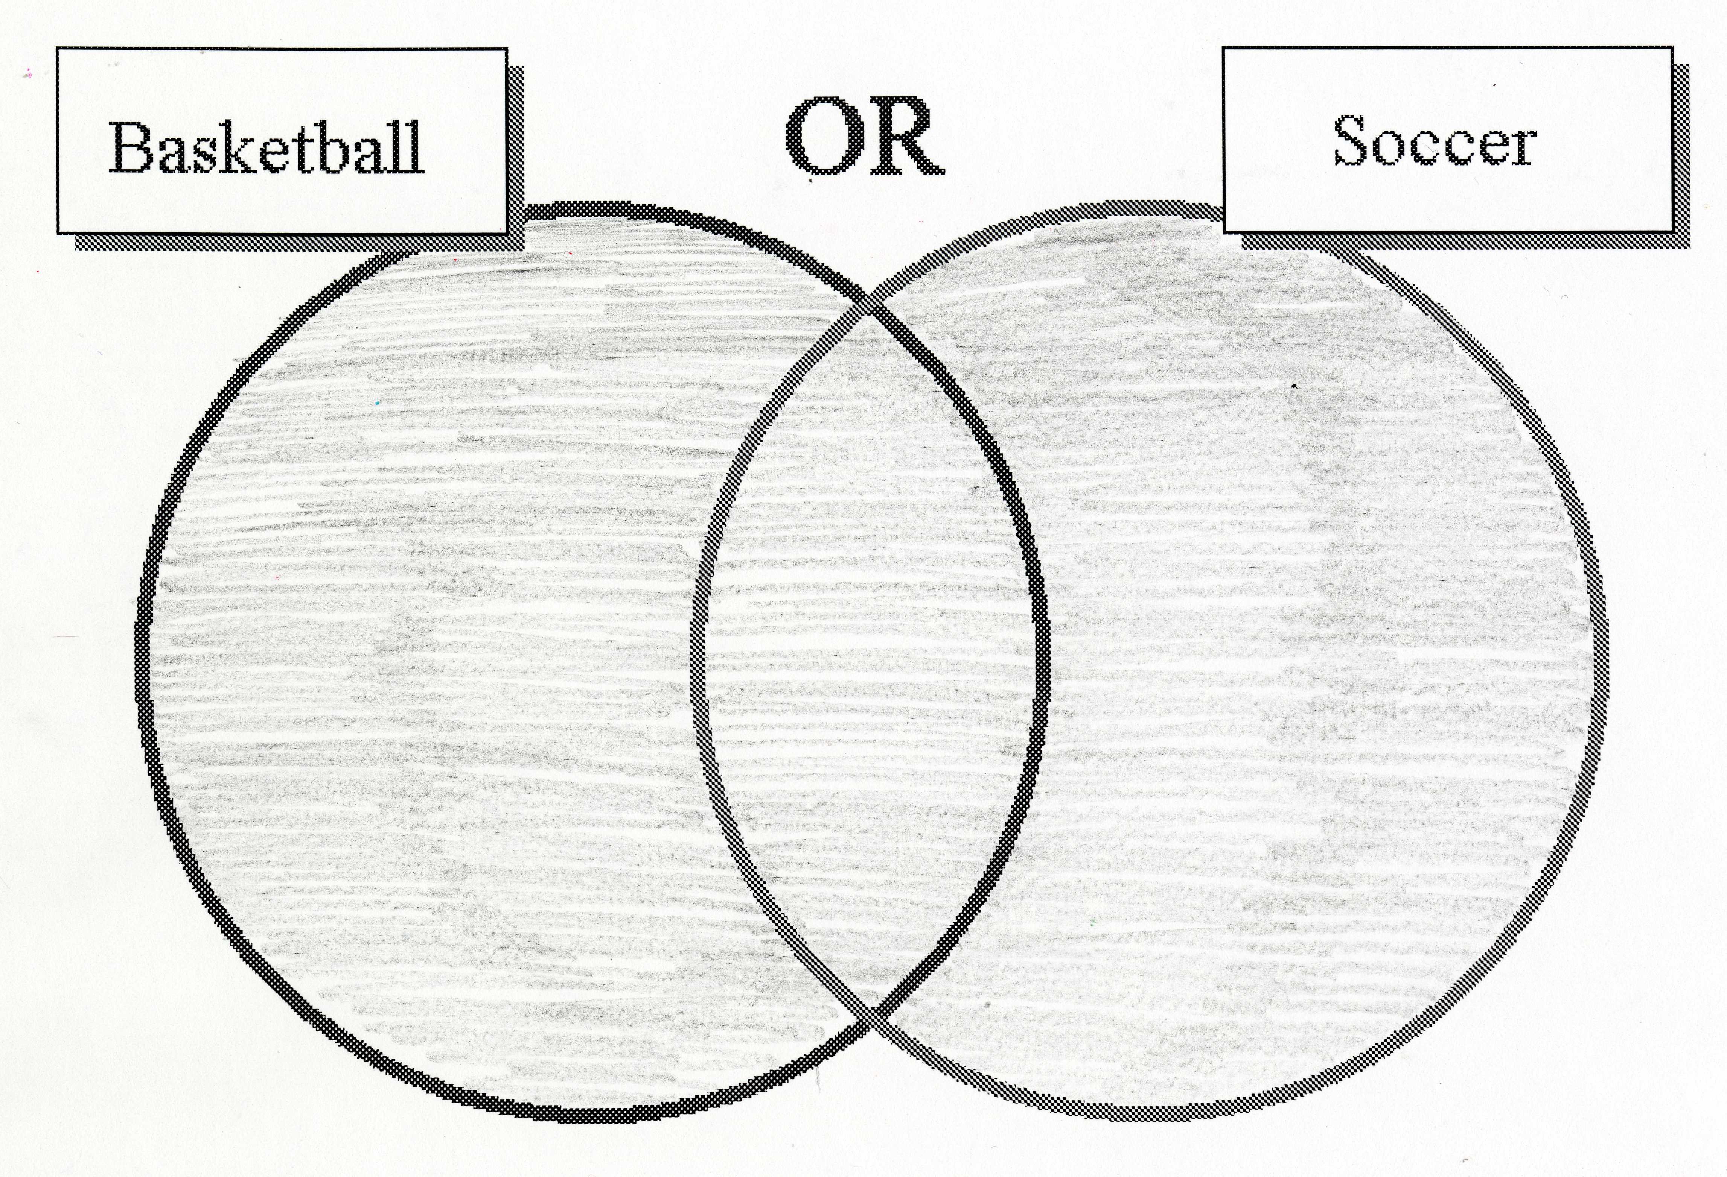

You want to find camps in Westerville Ohio that have basketball but NOT soccer.  Type in search box:  Basketball NOT soccer camps Westerville Ohio | 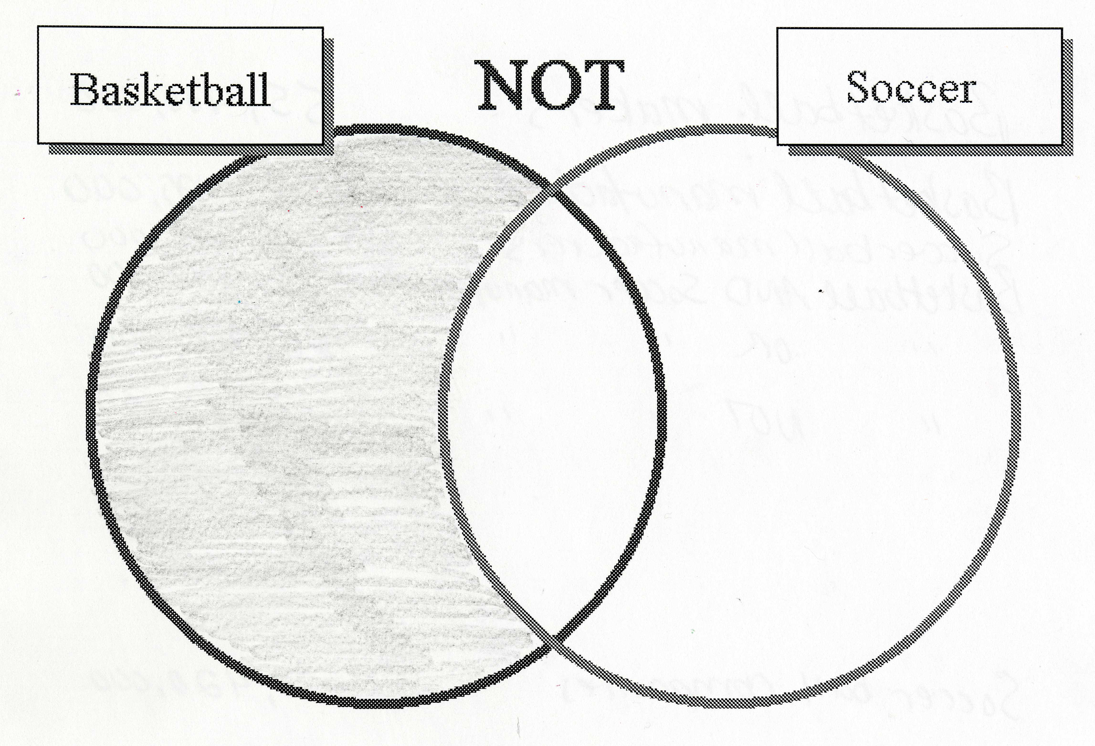

You want to find camps in Westerville Ohio that have both basketball AND soccer.  Type in search box:  Basketball AND soccer camps Westerville Ohio | 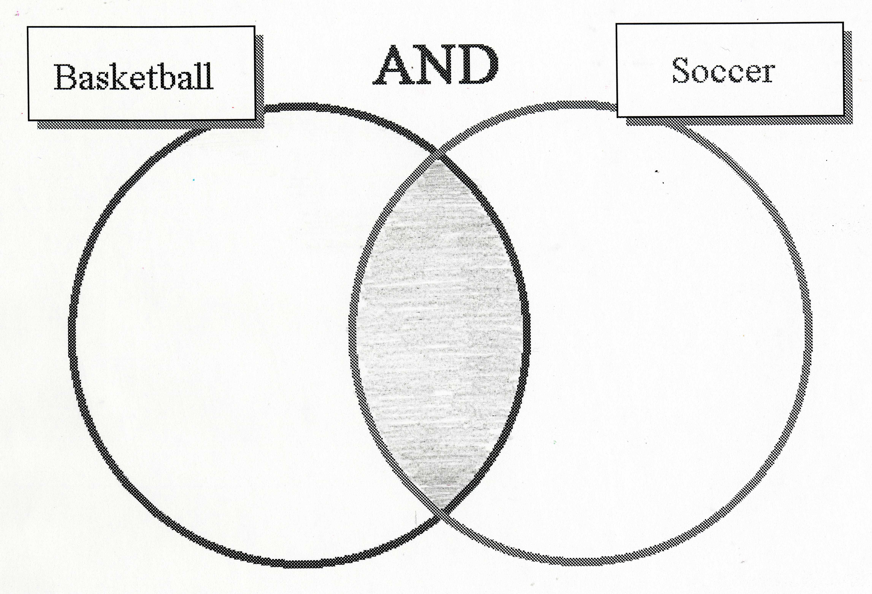
Search engines and web sites should:
- be easy for you to understand
- give you the best answers



Suggested Search Engines For Students (instead of Google)
http://www.askkids.com
The “Answers” Link provides answers to many questions about many things.

http://kidsclick.org
Search by category or Dewey Decimal Number (plus, tons of pictures!)

http://www.yahooligans.com
This is the same as http://kids.yahoo.com Once there, click on “Studyzone” to research many topics.

Great Research Websites
http://gws.ala.org
ALSC Great Websites For Kids – this is a portal that includes numerous websites on animals, the arts, history & biography, literature & languages, math & computers, science, social studies, and reference.

http://www.ipl.org/div/kidspace/

Internet Public Library Kidspace

http://www.infohio.org
INFOhio - Click on button that says “Resources for Grades K-5”

And explore all of the fantastic resources this site has to offer!

Government Resources | Premium Resources  (may need library card to access some of the sites)
http://www.unclesamsearch.com  Custom SE that only retrieves results from government websites  http://www.kids.gov/  Kids.gov | http://www.westervillelibrary.org  WPL - Click on “Online Collections”  http://www.columbuslibrary.org  CML - Click on “Reference / Premium Resources”

W W W . L I K E A G O O D B O O K . C O M

