(Thinking Inside The Box Program Kit)

Air

Grades K-2

CONCEPTS INTRODUCED:

Air is all around us. Even though we cannot smell, taste, or see air we can feel and see its effects. Air changes the way objects look, move and feel.

GOALS / OBJECTIVES:

- Learners will discover that air is all around us
- Learners will discover that air has weight
- Learners will discover that the weight or air can be changed
- Learners will discover that air can move objects producing kinetic energy.

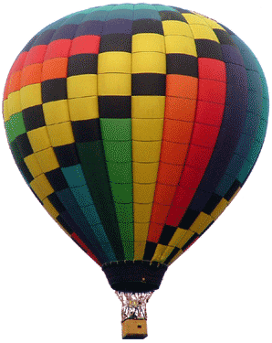

SUGGESTED PROGRAM OUTLINE

Before the program begins:
- Set up #2 activity described below
- Set up #6 activity described below
- Prepare paper bags (for step #7) and place on table
- Consider “modifications” to craft
- Display books in the kit on various tables during the program
- Place several copies of Bibliography and/or Webliography on table for participants to take home.

Once program begins:

- Introduce yourself to the audience. Ask the listeners if they can see, smell, or taste air? Ask listeners if they think air weighs anything?
- Activity: Weighing Air (see activity information below)
- Have participants sit down in front of you while you read a story.
- Read the book Air by Maria Rius
- Ask the listeners if there is a way to make air lighter?
- Activity: Up, up, and away - demonstrating what happens when air becomes warmer (a completed prototype may already be included in kit).
- Have the participants take a paper bag sitting on a side table (or can pass out to them). The paper bag will have a balloon, string, and feather inside of it. Participants will use these items to interact during the second story. Ask the participants to sit down in front of you for the second story.
- Read the book Let’s Try It Out in the Air by Seymour Simon and Nicole Fauteux
Note: If you do not have a lot of participants, you can also do the paper airplane activity described in the book. However, this could be very distracting with a large group of children. Use your discretion.
- Game: Parachute play - Have children stand in a circle and grab one of the handles of the parachute. Explain to the children that they will throw the parachute up into the air (not letting go of the handles) and then run inside the parachute and sit down along the inside edges. Once inside, explain how the air inside the parachute is keeping it inflated.
- Craft: CD Hover Craft (see instructions below) – this is an easy craft that shows young children how air can make things move via air pressure.

LIST OF SUPPLIES NEEDED

QTY | ITEM | PRICE
1 ea. | Yardstick | 1.00
1 pr. | Scissors | 5.49
1 roll | Ribbon | 1.00
1 roll | String | 1.00
1 roll | Masking tape | 2.12
1 ea. | Pencil | .05
1 pc. | Scrap paper (for activity) | 0.00
1 ea. | 12 ft. Play Parachute | 27.95
50 ea. | Paper bags (small lunch bag size) | 12.99
100 ea. | 7 or 8” balloons (25/pk is $1 @ Dollar Store) | 4.00
50 ea. | Feathers | 1.00
50 sht. | *Sheets of white paper (for airplanes) | 2.00
10 ea. | Paper cups | 1.99
10 ea. | Large, thin plastic bag  Recycling idea: use plastic grocery bags | 0.00
1 ea. | Hair Dryer | 9.97
50 ea. | CDs or DVDs  Recycling idea: you could ask coworkers to save the (AOL, etc.) CDs & DVDs that come in the mail and bring them into the library to include in this kit) | 12.99
50 ea. | Bottle caps  Recycling idea: ask coworkers to save the caps from their soda bottles and bring them into the library to include in this kit. | 0.00
1 ea. | Hot glue gun  Suggest AdTech Craft Dual Temp Cordless Glue Gun – can order off their website http://www.ad-tech-craft.com for $12.99 plus $6.95 s/h | 19.94
1. pkg. | Hot glue sticks  Suggest AdTech Craft Economical General Purpose Glue Sticks (229) 5/16” x 4” 400 count pack $20.95 plus $7.95 s/h | 28.90
 | TOTAL | $132.39
* optional items – depending on the amount of participants

CONTENTS OF KIT
MUST BE RETURNED:
Qty | Description | √
1 ea. | Yardstick
1 pr. | Scissors
1 ea. | Pencil
1 ea. | 12 ft. Play Parachute
1 ea. | Hot Glue Gun
1 ea. | Hair Dryer
1 ea. | Pebble
1 ea. | Up, Up and Away cup/bag activity if still usable
Book | Air and Flight by Sally Hewitt
Book | What makes it go? What makes it work? What makes it fly? What makes it float? by Joe Kaufmann
Book | Air by Darlene Lauw and Cheng Puay
Book | Up in the air by Wendy Madgwick
Book | Air by Bryan Murphy and Sally Kindberg
Book | Wind and weather: climates, clouds, snow, tornadoes, and how weather is predicted by Liane Onish
Book | The science of air: projects and experiments with air and flight by Steve Parker
Book | Air by Maria Rius and Jose Maria Parramon
Book | Let's try it out in the air: hands-on early- learning science activities by Seymour Simon, Nicole Fauteux, and Doug Cushman
Book | Air and water by Richard Spilsbury
Book | Experiments with air by Salvatore Tocci and Patricia Rasch
CONSUMABLES:
Qty | Description
1 roll | Ribbon
1 roll | String
1 roll | Masking Tape
1 pc | Scrap Paper
50 ea. | Paper bags
100 ea. | Balloons
50 ea. | Feathers
50 ea. | Sheets of White Paper
50 ea. | CDs or DVDs
10 ea. | Paper cups
10 ea. | Large, thin plastic bags (grocery bags)
50 ea. | Bottle Caps
1 pkg. | Hot Glue Sticks
50 ea. | Webliography Handout
10 ea. | Promotional Flyer
ACTIVITY: WEIGHING AIR
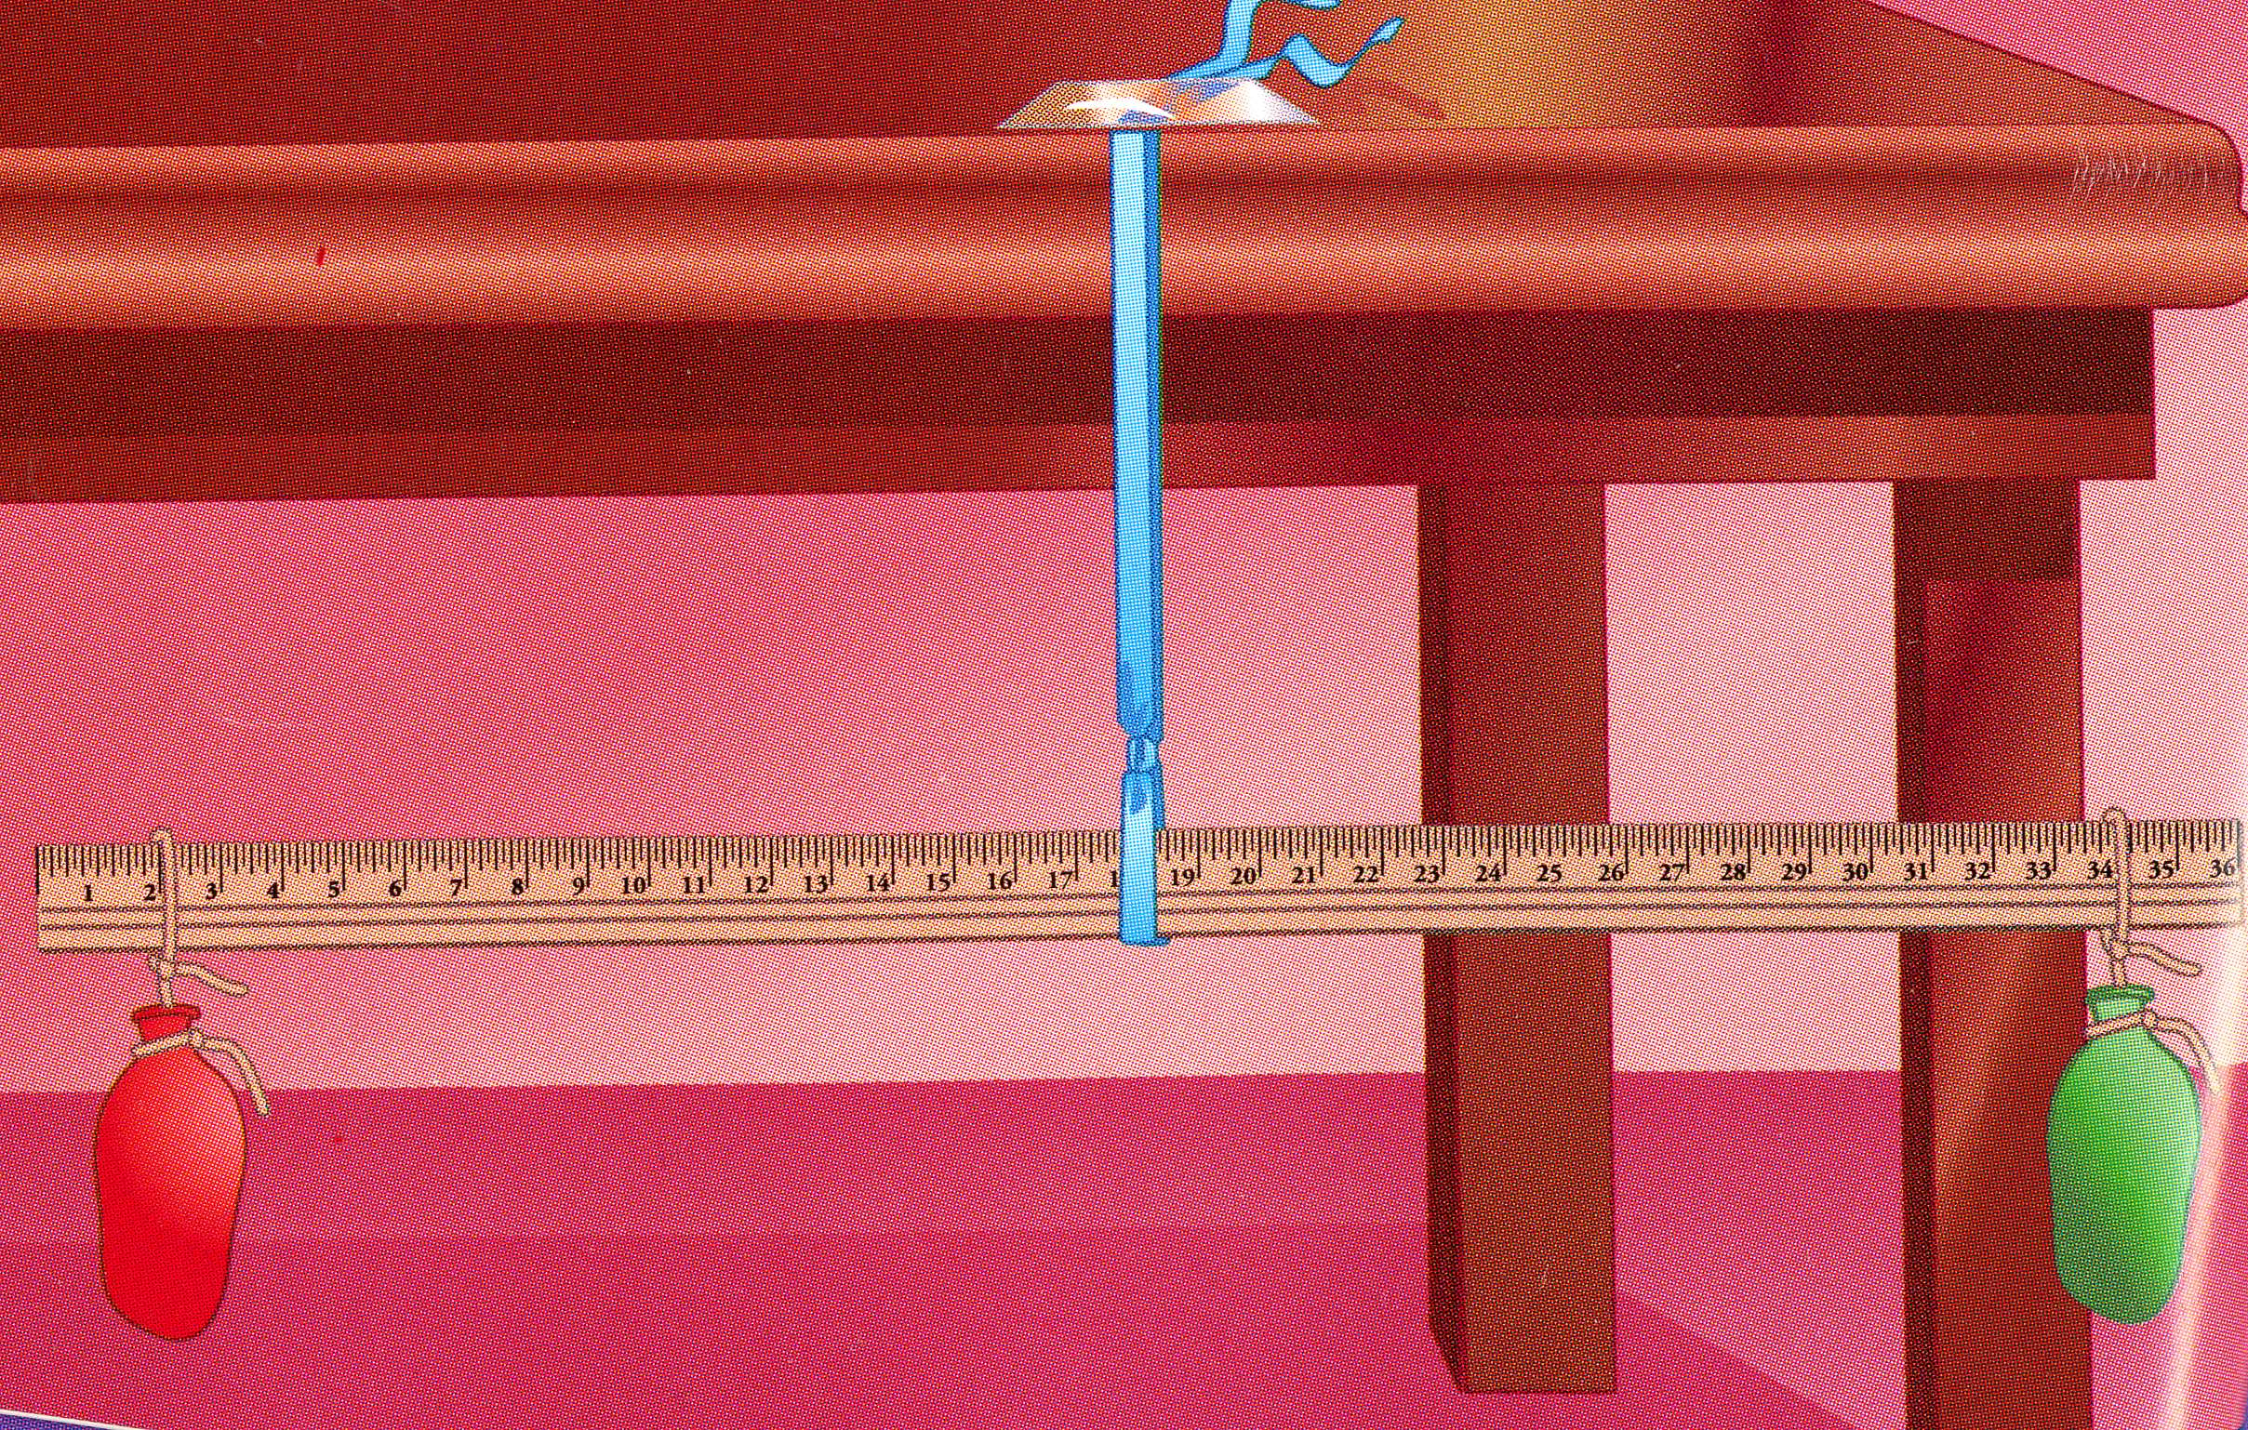
Supplies Needed:
- 1 table
- 1 pair of scissors
- 1 yardstick
- 2 balloons
- 2 ft of ribbon (any color)
- string
- tape
- pencil
- paper

Directions (before program starts):

- Use string to attach a balloon (deflated) to the each end of the yardstick
- Tie one end of the ribbon around the middle of the yardstick
- Tape the other end of the ribbon to the side of a table so the yardstick hangs freely underneath the table
- Slide the ribbon where needed on the yardstick so the two balloons are balanced (yardstick will be level)
- With a pencil and paper, make a note of where you placed the balloons

Directions (after program starts):

- Carefully remove one of the balloons from the yardstick
- Blow up the balloon and tie it so the air does not escape (explain to the children that when a balloon is blown up, the air pressure inside the balloon slowly becomes greater than the air pressure outside the balloon. Since the balloon is made out of rubber, or latex, it is able to expand, or grow larger. “When the balloon is popped, the air escapes instantly. The sound you hear is from the molecules of air inside the balloon coming into sudden contact with the molecules of air outside the balloon.”)
http://kids.earth.nasa.gov/archive/air_pressure/results.html#2
- Use the string to attach the balloon to the spot where it originally was on the yardstick. What happens to the yardstick?

Discussion:

Before you blew up the balloon, the yardstick was level. But the balloon filled with air made the yardstick tilt down. This means that the balloon filled with air weighed more than the empty balloon. So air has weight. Because it has weight, air can push against objects. Ask listeners what kinds of objects air can push against.

Taken From: Tocci, Salvatore, and Patricia Rasch. Experiments with air . New York: Children's Press, 2002. Print

ACTIVITY: UP, UP AND AWAY

Supplies Needed:
- Scissors
- Small paper cup
- Four strings (ea. 8” long)
- Large thin plastic bag (plastic grocery bag)
- Pebble
- Hair dryer

Directions:

  - Use the scissors to poke four holes around the top edge of the paper cup
  - Knot one string in each of the holes
  - Tie the four strings to the handles of the plastic bag
  - put the pebble into the cup to act as a weight
  - Ask a participant to hold the bag while you fill it with hot air from the hair dryer
  - Use the hottest setting on the dryer and hold it just below the opening of the bag
  - Release the bag and watch it float

Discussion:

“Hot air is lighter because it weighs less than cool air. In the experiment, the hot air from the hair dryer filled the bag. The bag was then full of warm air that was lighter than the cooler air surrounding the bag, so the warm air in the bag rose and carried the hot-air balloon upward.”

Taken From: Lauw, Darlene, and Cheng Puay Lim. Air . New York: Crabtree Pub., 2003. Print. pages 13-14.

Note:

This item could be reused from program to program eliminating creating it each time.

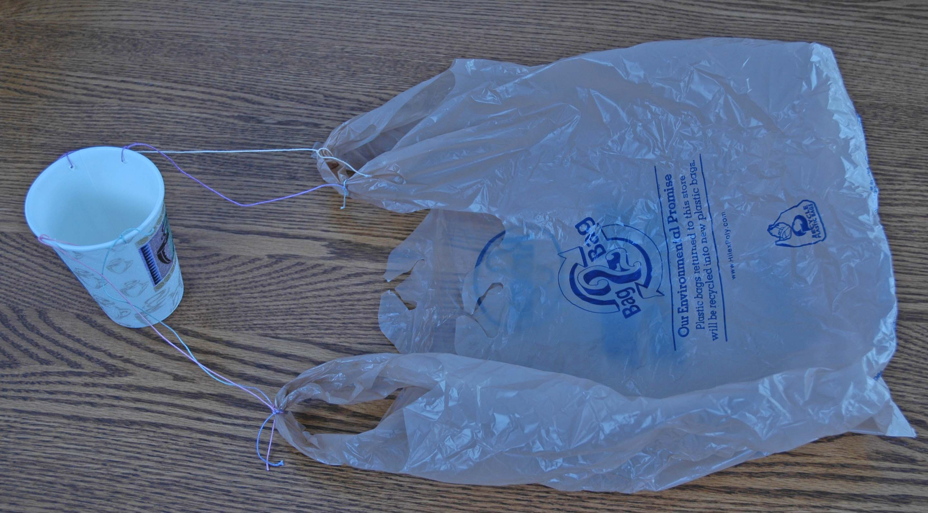
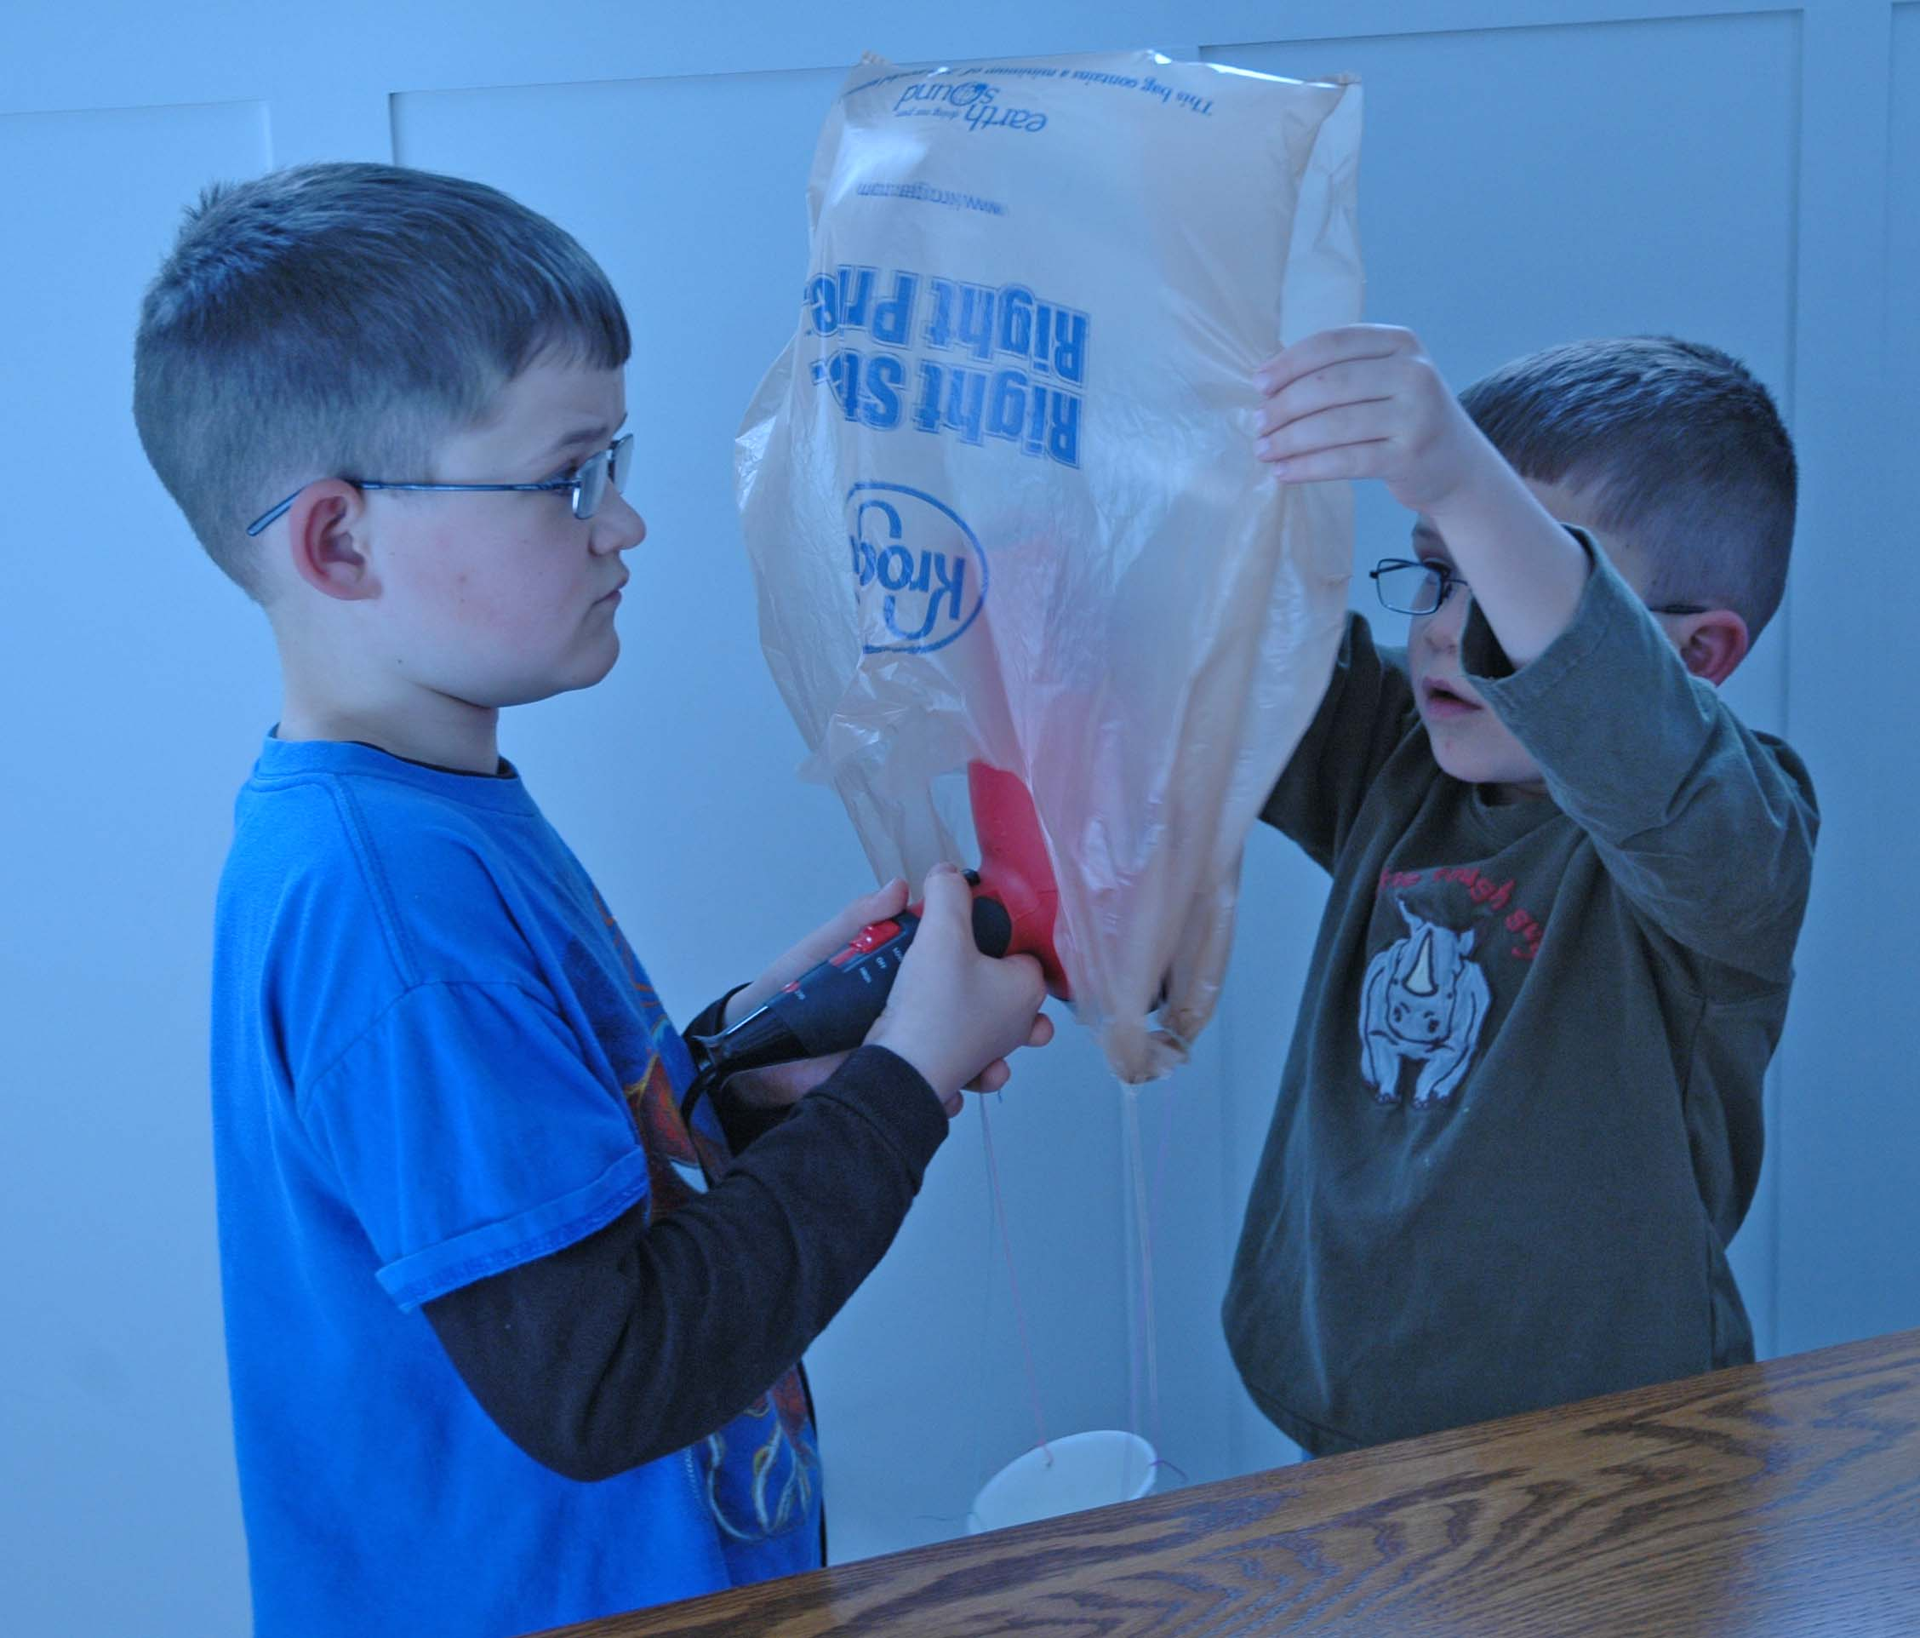

CRAFT: CD HOVER CRAFT

Supplies Needed:
- Sharp Scissors
- Plastic Bottle Caps
- Strong Glue (Hot Glue)
- Hot Glue Gun
- Ordinary CD or DVD
- Balloons

Directions:

- Make a 1/8” hole in the center of the cap by piercing it with the scissors. Slowly rotate the scissors, widening the hole.
- Glue the flat side of the cap to the center of the CD or DVD so that the holes align, and let the glue dry.
- Blow up the balloon and twist the end tight (but do not tie off)
- Carefully roll the balloons “lip” over the edge of the cap.
- Place the CD or DVD on a smooth surface and release.

The “hovercraft” should slide easily along the surface after having had the slightest touch.

Modifications:

- If you’re going to have a lot of participants, try completing steps #1 (and #2) before the program begins.
- You can skip step #3 and go straight to step #4 and then hold the balloon’s “lip” in place with your hand while you blow the balloon up by blowing through the hole in the CD/bottle cap
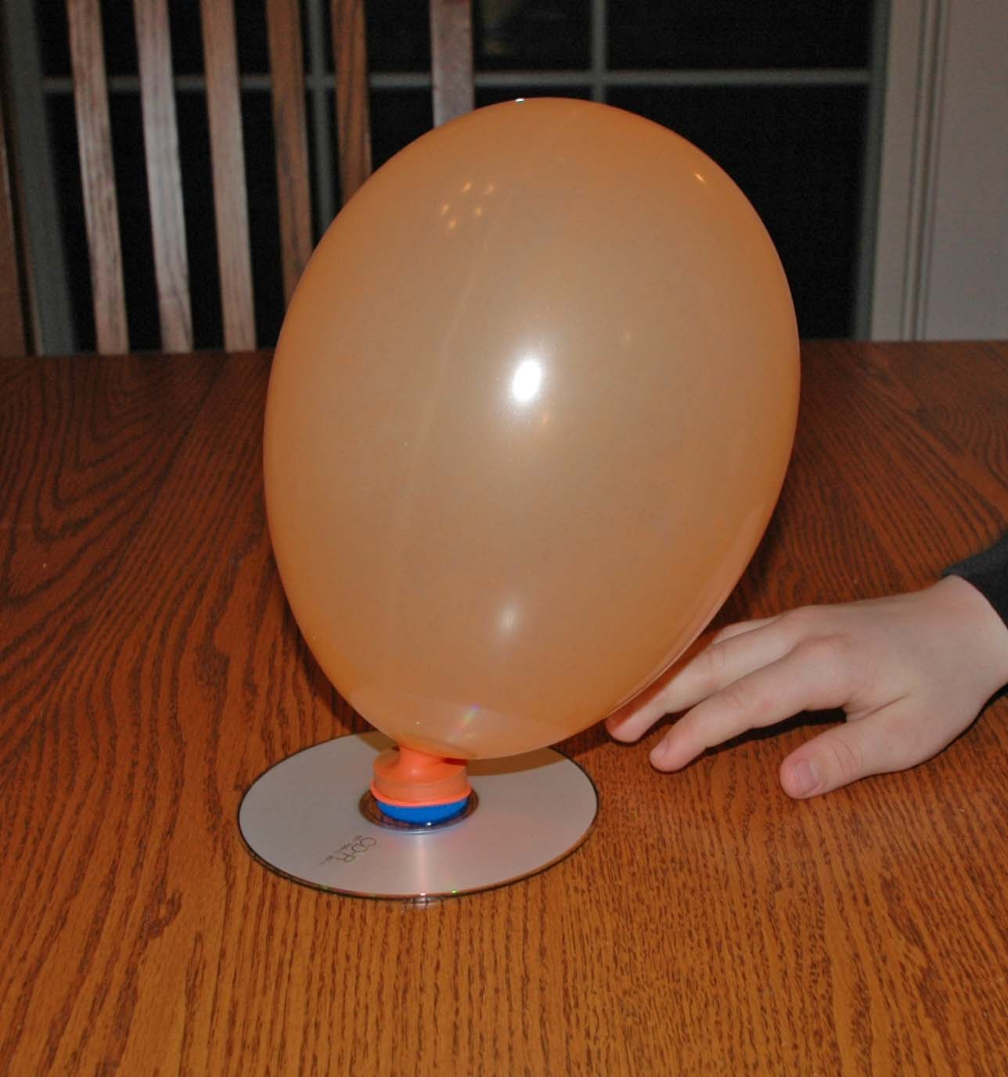

Taken From: Connolly, Sean. The book of totally irresponsible science . New York: Workman Pub., 2008. Print. Pg. 106-107.
BIBLIOGRAPHY

Hewitt, Sally. Air and flight . New York: Children's Press, 1999. Print.
Each chapter of this book is about two pages long. Terms are explained in an easy-to-understand way and are accompanied by many images to support the text. Chapters also feature separate sections: “Think About It!” – encouraging reader to engage in higher-level thinking; “Look Again” – referring the reader to other sections of the book for review; and “Try It Out” – providing the reader with experiments and activities to support the text.

Kaufman, Joe. Joe Kaufman's what makes it go? What makes it work? What makes it fly? What makes it float? . New York: Golden Press, 1971. Print.
This is an old, but classic, large picture book that explains how things work. Pages 26-31 provide information on how things fly. The color, cartoon-like illustrations are appealing to young readers. Pages 26-27 would be great to use at the beginning of the program or explanation. The text is easy to understand and the images are fun and colorful.

Lauw, Darlene, and Cheng Puay Lim. Air . New York: Crabtree Pub., 2003. Print.
Simple text describes what air is, how much oxygen is in air, effects of air temperature, air in motion, air pressure, and flight. The book includes a glossary and index as well as short chapters with colorful images and illustrations.

Madgwick, Wendy. Up in the air . Austin, Tex.: Raintree Steck-Vaughn, 1999. Print.
This book is full of step-by-step instructions for activities designed to prove air is all around us. All of the activities in this book are easy to administer and require very few materials. The text font is large and the illustrations are colorful. The back of the book features a glossary and suggestions for further reading.

Murphy, Bryan, and Sally Kindberg. Air . Chicago, Il: World Book, 2000. Print.
This book is chock-full of explanations and supporting activities pertaining to air. Each activity and experiment is described in detail with supporting photos and illustrations. There is also a word search and True or False questions towards the back of the book. The book includes an interactive CD that includes over 15 hours of activities, games, and adventures. CD is Mac and Windows compatible.

Onish, Liane. Wind and weather: climates, clouds, snow, tornadoes, and how weather is predicted. New York: Scholastic, 1995. Print.
This book is full of foldout pages, Lift-the-flap pages, plastic overlay pages, and even 3D pages (glasses included) used to help explain the concepts of air, weather, and changing climates. Pages are spiral bound for easy turning and the ability to lay the book flat. Pages are colorful and engaging and the final pages include book suggestions, people to know (in science), names of the winds, words to know, a timeline, and an index. The back cover includes a pocket with stickers.

Parker, Steve. The science of air: projects and experiments with air and flight. Chicago, Ill.: Heinemann Library, 2005. Print.
This is a large book with large print and images. The text is easy to read and easy to comprehend. Diagrams and illustrations explain concepts. Experiments include step-by-step instructions that are easy to implement.

Rius, María, and José María Parramón. Air . Chicago, Ill.: Childrens Press Choice, 19871984. Print.
This is one book in a series of four pertaining to the four elements: earth, fire, air, and water. This is a fantastic book for young readers. Each two-page spread includes a short (4-8 word) sentence with either a full-page illustration or two-page spread illustration. The text is large and easy to read. The watercolor illustrations are colorful and beautiful. This would be a great book to read during a library program. It’s short and informative in simplest terms.

Simon, Seymour, Nicole Fauteux, and Doug Cushman. Let's try it out in the air: hands-on early- learning science activities. New York: Simon & Schuster Books for Young Readers, 2001. Print.
This is a great book to be used during an interactive storytime. The text is large and easy to understand. The illustrations are large, colorful, and easy for a large group of children to see from far away. There are many interactive activities included for children to participate in during the reading of the story.

Spilsbury, Richard. Air and water pressure . Chicago, Ill.: Heinemann Library, 2006. Print.
Photo images and colorful illustrations bring the text in this story to life. Many concepts like air pressure, water pressure, and buoyancy are explained. Several experiments help support the content. The book includes a list of amazing facts, a glossary, an index, and a list of books and websites to explore.

Tocci, Salvatore, and Patricia Rasch. Experiments with air . New York: Children's Press, 2002. Print.
This book includes many experiments that explain the element of air. The colorful images and illustrations complement the colorful background of the pages. The text is large, bold and easy to understand.

WEBLIOGRAPHY

Clouds R Us
http://www.rcn27.dial.pipex.com/cloudsrus/pressure.html
Grades 3-5: This website explains air pressure in terms easy for younger students to understand. Extension: At the bottom of the page (under the heading “Highs and Lows”) there is an “Activities” link. Here, more advanced students can use the provided directions to create a barometer and record air pressure.

Energy Quest
http://www.energyquest.ca.gov/story/chapter16.html
Explains how air (or wind) moves many things in our environment including sails and turbine blades to create energy.

Kid Wind Project
http://learn.kidwind.org/
This site provides kids with basic information about wind power, project ideas and experiments. There are many activities included under the “Curriculum” tab, including how to make a turbine blade, how to make a hot air balloon, and measuring the swept area of a wind turbine. The site features many lesson plans posted for teacher and parent use and a KidWind challenge where kids can build their own turbines and compete against each other for the best design.

NASA Science
http://kids.earth.nasa.gov/archive/air_pressure/weather.html
Grades 3-5: A great article explaining how weather affects air pressure.

NASA Science
http://kids.earth.nasa.gov/archive/air_pressure/index.html
What happens when air pressure changes? This and other questions are investigated with experiments on this website.

Smithsonian: National Air and Space Museum
http://www.nasm.si.edu/exhibitions/gal109/NEWHTF/HTF200.HTM
How Things Fly: An exhibition at the National Air and Space Museum
Click on “How Do Things Fly” and then on “Air is Stuff” to get an explanation of air and why it doesn’t crush humans to pulp.

PROGRAM EVALUATION

Please fill out and return inside the kit.

Program Date
Program Time
Program Presenter
# of student attendees |  | # of adult attendees

What went well:

What didn’t go well:

Suggestions for improvement:

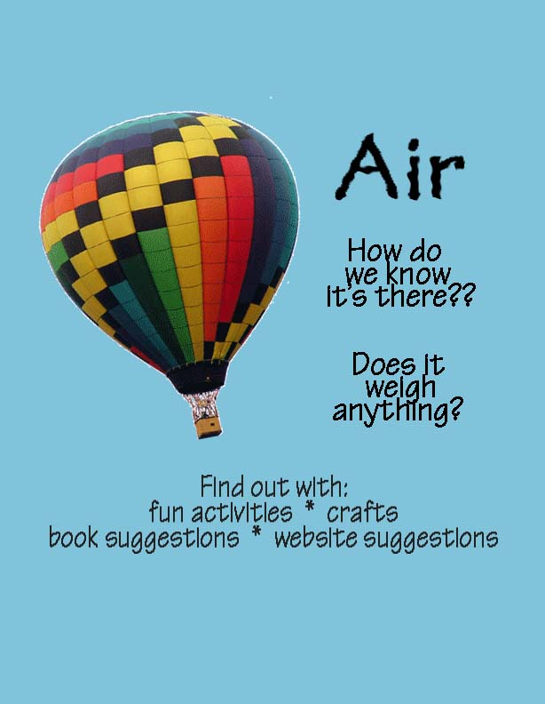

(place date and time information here)

